**The Vampire Diaries Season 9** 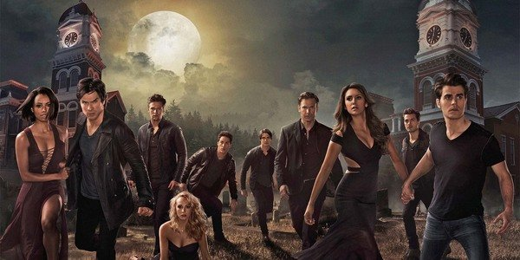

**The Vampire Diaries**, an American mystical teen drama series developed by Julie Plec and Kevin Williamson, bottomed on the highest selling book series of the same title written by L.J. Smith. It has **8 seasons**. First was streamed on September 10, 2009 and then final episode of **season 8** was broadcasted on march 10, 2017. It’s one of the most popular series with a huge fan following. From the day last episode was streamed, its die-hard fans are eagerly waiting to see their loving characters Elena, Damon, Stefan, Caroline and others in the next **season 9**. 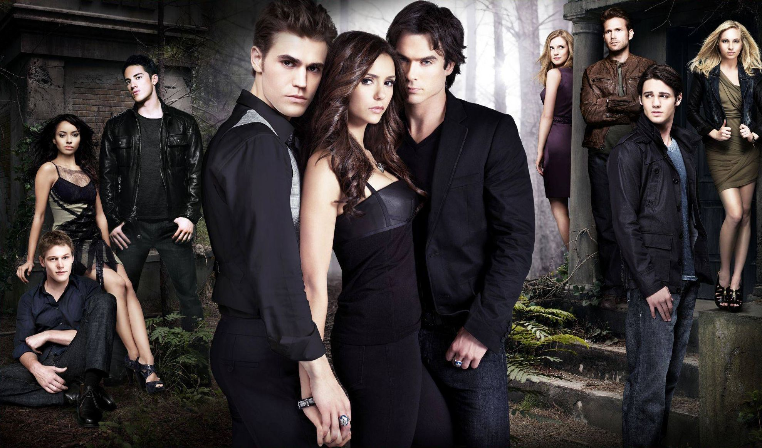

**Release Date:**

The makers of the series publicized on July 23, 2016 that **season** 8 comprising of 16 episodes will be the last *season*. And they concluded the series on march 10, 2017. So, chances for renewal of a new season seems to be so meagre. In spite of fan’s demand, the makers of the shows are not intended to create another season. They stated that they’re jovial over the ending in the *season* 8 and thus they’re neither planning for another season nor working on any spinoffs. Originals and Legacies are two spinoffs of The Vampire Diaries. Legacies is still in continuation. For renewal of **season 9**, the protagonist of the Vampire Diaries does not wish to play their role again. Nina, Paul and Ian declined to reprise their role as of now. But if in future they’re willing to comeback then *season 9* will consist of 22 episodes as the most of seasons consisted of 22 episodes. Even though chances are very meagre for another *season* but still if it comes anyhow then the below mentioned is the list of **possible cast**:

*Nina Dobrev* being Elena Gilbert

*Paul Wesley* being Stefan Salvatore

*Ian Somerhalder* being Damon Salvatore

Kat Graham being Bonnie Bennett

Candice King being Caroline Forbes

Matt Davis being Alaric Saltzman

Joseph Morgan being Klaus Mikaelson

So, conclusion is the creators will create **season 9** of **The Vampire Diaries** but they need the lead actors to play their part. So, as of now season 9 creation is indefinite, but we can wish that may be some day there’s some official announcement regarding the same. Till that time, you can enjoy **The Vampire Diaries** (8 seasons) and their spinoffs The Originals and Legacies.